Ankita Durgude

Assignment –7

Summarizing Data with Aggregate Functions.

1. **Write a query that counts all orders for October 3.**

**Ans:** select Odate,count(Odate) as 'count of orders' from orders where Odate='03-10-1990';

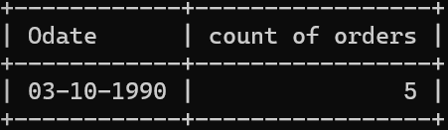

1. **Write a query that counts the number of different non-NULL city values in the Customers table.**

**Ans:** select count(distinct city) as 'unique cities' from customers where city is not null;

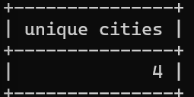

1. **Write a query that selects each customer’s smallest order.**

**Ans:** select Onum,min(amt) as 'smallest order' from orders group by Onum;

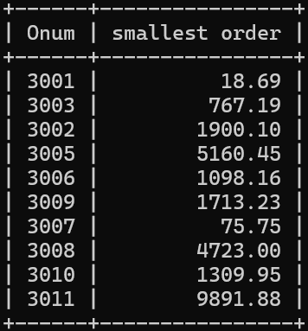

1. **Write a query that selects the first customer, in alphabetical order, whose name begins with G.**

**Ans:** select Cname from customers where Cname like 'G%' order by Cname;



1. **Write a query that selects the highest rating in each city. Ans:** select City ,max(Rating) from customers group by City;

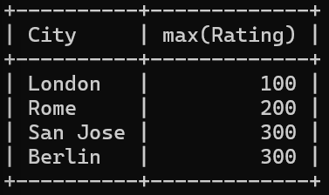

1. **Write a query that counts the number of salespeople registering orders for each day. (If a salesperson has more than one order on a given day, he or she should be counted only once.).**

**Ans:** select Odate,count(distinct Snum) as 'Unique Snum' from Orders group by Odate;

